Professional Accountancy Organisations
Strategy Toolkit

Professional Accountancy Organisations

Strategy Toolkit



PAO Strategy Formulation





Contents
1 Glossary of Terms 3
2 Description of the toolkit 4
3 Current Assessment and Baseline 6
3.1 Strategy Review 6
3.2 Financial Position 6
3.2.1 Product Life Cycle phases 7
3.3 Stakeholder Map 8
3.4 Top Risks 9
3.5 Competitor Analysis 9
3.6 Focus Interviews 9
3.6.1 How to Conduct the Focus Interview 11
3.6.2 Mandate of the PAO 11
3.6.3 PAO aspirational statements, vision, purpose 12
3.6.4 Environmental context 12
3.6.5 Critical success factors; key risks and barriers 12
3.6.6 Competitor analysis 12
3.6.7 SWOT (Strengths, Weaknesses, Opportunities and Threats) Analysis 13
3.7 Assessing Strategic Maturity 13
3.7.1 Analysis 13
3.8 Pre-presenting 13
3.9 Workshop (s) 13
3.9.1 Facilitation 14
3.9.2 Facilitation tools 14
3.10 Bringing it all together… 15
4 Design 16
4.1 Balanced Scorecard Approach to strategy 16
4.2 Vision Statement or BHAG – Big Hairy Audacious Goal 17
4.3 Mission Statement 18
4.4 Values 19
4.5 Business Model 20
4.6 Critical Success Factors [CSFs] 20
4.7 The Strategy Map 20
4.8 Measurement 25
4.8.1 Measures 26
4.8.2 Lead and Lag measures examples 26
4.8.3 Targets 27
4.8.4 Measure detail sheet 27
4.9 A typical Example of a Balanced Scorecard for a PAO 0
4.10 Roadmap of Initiatives 0
4.11 Bringing it all together 0
5 Implementation Planning 1
5.1 Charter 2
5.2 Resourcing 2
5.3 Stakeholder Management 0
5.4 Risk Schedule 0
5.5 Communications Plan 0
5.6 Budgets 0
5.7 Bringing it all together 0
6 Monitoring and Evaluation 1
6.1 Plan, Do, Review 1
6.1.1 The Process 1
6.1.2 By way of example 1
6.2 Project Management 2
6.3 Bringing it all together 2

Glossary of Terms
PAO | Professional Accountancy Organisation
IFAC | International Federation of Accountants
SMO | Statement of Membership Obligations
SWOT | Strengths, Weaknesses, Opportunities, Threats
PESTLE | Political, Economic, Social, Technological, Legal, Ecological
BSC | Balanced Score Card
PAFA | Pan African Federation of Accountants
CSFs | Critical Success Factors
PDR | Plan, Do, Review
IR | Integrated Reporting

Acknowledgements

The Professional Accountancy Organization strategy formulation toolkit was designed by the Federation with technical support from the World Bank. A special thanks is extended to Patrick Kabuya (Senior Financial Management Specialist, Task Team Leader), and Rakesh Beekum (Project Consultant) who facilitated the design of the strategy.

Top Tips
Look out for tips and pointers included throughout the strategy toolkits.

Description of the toolkit
The PAO strategy toolkit has been specifically designed in a simplified format to guide the PAO in its strategy design process. While it is in a simple strategy toolkit format, it uses powerful tools and assessments to guide the PAO though the strategy formulation process. The toolkit takes an integrated thinking approach* in its design.
*Integrated Thinking takes a holistic approach of determining the inter-relatedness of the strategic actions from various capitals such as financial, social, human, physical, natural, and intellectual. The concept comes about from the Integrated Reporting Framework that creates a focus on where value is created (and destroyed). More information on Integrated Reporting can be found at www.theiirc.org.
The strategy also aligns to the IFAC SMOs.
The toolkit has three design blocks and one tracking block, namely:

Within the design blocks (or phases), it requires the PAO to execute a number of activities in order to achieve the design block’s deliverables. The activities and deliverables in each design block contribute to the next design block.
Each design block is packed with tools to enable the PAO in formulating its strategy.
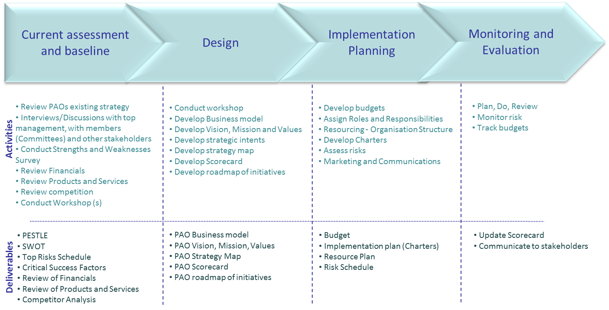
Strategy Approach

The toolkit has been designed to have a roadmap to execute the strategy formulation.

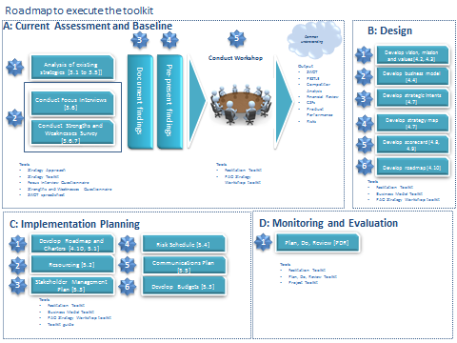

Current Assessment and Baseline
The Current Assessment and Baseline phase aims to assess where the PAO currently is in its organisation strategy. As the first phase, it demands a considerable amount of analysis. The process allows for wide participation and engagement with the PAOs stakeholders.

Strategy Review
As we begin the strategy formulation process, the PAO would need to review any existing strategies and past performance. The review can include the PAO’s business strategy, financial strategies, marketing strategies, IT strategies, Member Service strategies, etc. During the review, it will be important to understand what is working well and what is not working well.

Financial Position
During the strategy formulation journey, it would be necessary to document the past financial performance of the PAO. The financial performance must be done over the past five years from an income statement perspective. Identify the sources of revenue and the products that have performed well and not-so-well. Using the matching principle, associate the costs to the sources of revenue over the period of five years.
Following the “money-trail” is an essential key ingredient in the strategy formulation process. It will be important to understand the PAO’s revenue sources and even more important in understanding the revenue mix. The revenue mix is determined as the ratio of membership revenue to other sources of income. A large reliance on subscriptions only may not be a sustainable business model.

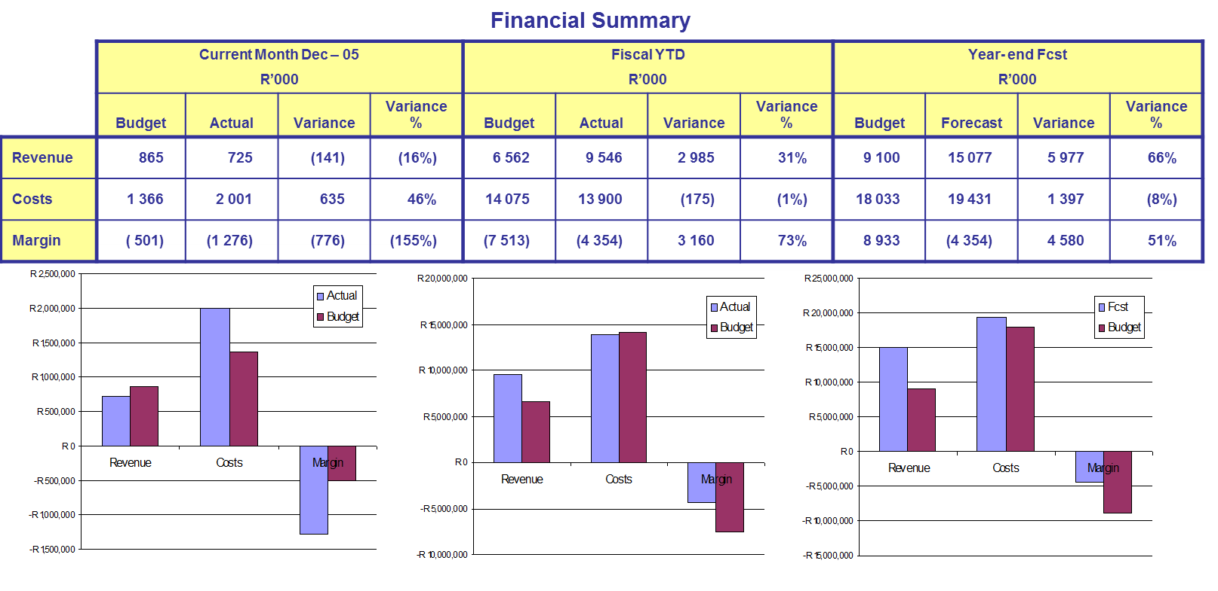
Above, is an example of how the financials can be presented.
Product lifecycle – each source of revenue represents a product (this can also be a service, so product is meant to represent a service or a product). The product phase must be assessed so that the actions can be determined for each of these products.
While the PAO may not be ‘for-profit’, a particular product may make profit so that it can cross-subsidise other PAO activities or projects that may not be ordinarily funded by its subscriptions.

Product Life Cycle phases
- Introduction
- Growth
- Maturity
- Decline
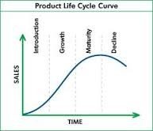
The S-Curve depicts where a product lies in its life-cycle and marketers use the S-Curve to determine the appropriate types of activities and for each part of the life-cycle. The PAO can also determine what capabilities it may require for each phase.
Example
Product | Life-cycle stage | Member or Stakeholder Satisfaction Rating | Profit Margin | Analysis and recommendations
International Conference | Introduction | 65% | 48% | Good top-line revenue and margin. Stay focused and mobilise marketing resources
Tax Conference | Maturity | 89% | 63% | Consider rejuvenating the Tax Conference so that it does not decline.
Books | Decline | 55% | 6% | Too low margins for the effort. Consider e-books and leverage the website.
etc

Top tip
The PAO can make an assessment as to where it is in its life-cycle based on the S-Curve. By using this S-Curve, it can decide on the appropriate set of capabilities. These capabilities can support the different stages of the organisation’s life cycle.

During this process, also identify strengths and weaknesses; and the opportunities and threats to each revenue source.
Top Tip
Always consider the integrated thinking approach, by considering the impact of all the other capitals when discussing the financial capital.

Top Tip
Think about the financial long term critical success factors, what might be the financial objectives and how it can be measured.

Stakeholder Map
The stakeholder map takes a holistic view of identifying the key stakeholders in the PAOs interactions. The stakeholder map can also be used to identify blockers, critics, neutrals and supporters. Use the stakeholder map to schedule focus interviews as appropriate.

Top Risks
The Top Risks can be used during the strategy formulation process that are normally identified by the PAOs enterprise risk management process to cross-validate the SWOT and PESTLE issues. If an enterprise risk management process does not exist, then the Board, Audit or Executive Committee would supply the PAOs top risks.
During this process, the PAOs, risk register can also be created/updated/validated.

Competitor Analysis
Whilst a PAO acts in the public interest, there will be always be competition at a brand level, organisation level, a resource level, etc. The PAO would need to recognise the competitors and how to compete. The concept of coopetition is important on how the PAO excels in a cooperative competition environment. Whilst the PAO may directly compete with its competitor, it may cooperate on certain initiatives for mutual benefit. An example may be to create a higher value by cooperating with another competing PAO than focusing on a particular initiative on its own. By way of a practical example, an international conference held in a country could rally resources for an event that could create significant value by pooling resources in a cooperative manner.

Focus Interviews
In this phase, we begin with the focus interview instrument that allows one to collect information from the key stakeholders.
Key stakeholders are both from within the PAO and external to the PAO. The internal PAO stakeholders are the Chief Executive Officer and Senior Management, while the external stakeholders are Committee members (example, Chairman of the Board, Chairman of the representative bodies, influential members or members in influential positions; members/directors of the state).
The focus interview instrument is a guide and the interviewer must explore other issues that are important to the PAO from a strategy perspective. The stakeholders might have not documented their thinking but it would be important to probe their minds to elicit this tacit knowledge.
The focus interview instrument will elicit important information such as:

The instrument is used as a change management tool to be inclusive of all types of stakeholders and making them ‘heard’ and part of the strategic management process.
The interviews must be confidential and the interviewee’s anonymity should be maintained unless permission is given.

How to Conduct the Focus Interview
- Preparation of the Interview:
☒ Did you agree a location?
☒ Did you agree a start time?
☒ Did you check the hygiene factors (interviewee had a drink etc)?
☐ Did you check the name and position of the person being interviewed?
- Execution of the Interview - Introduction:
☐ Did you introduce yourselves?
☐ Did you explain the purpose of the interview?
☐ Did you confirm/clarify the time contract?
☐ Did you confirm interviewee’s position/capacity?
☐ Did you outline the framework of the interview and explain roles?
☐ Did you explain to what end the interview would be used?
- Execution of the Interview - Close:
☐ Did you finish with an open question (is there anything else you would like to tell me)?
☐ Did you agree/clarify any next steps and timings?
☐ Did you thank the interviewee?
- Follow-up:
☐ Are your interview notes in a readable form?
☐ Do you have any verbatim quotations?
☐ Are the key points summarized know who and when to feedback your interview notes?
☐ Have you quality checked the interview - do you think it is honest and accurate?
☐ Did you probe to examine real issues?
☐ Did I understand what is he/she really saying?

Focus Interview Questionnaire
The Focus Interview Questionnaire has been designed. This questionnaire must be sent to the stakeholder beforehand.
The Focus Interview Questionnaire is then used to create pull information together such as the PESTLE analysis, SWOT, vision, mission, etc.
All this information can be aggregated and put into a baseline document that will be used in the workshop to confirm the current assessment. This information will then be captured into the PAO Strategy Template.

Mandate of the PAO

- Establish if the PAO exists within a legal framework.
- Review the country’s regulations and, determine whether applicable to the PAO.
- Review and understand the existing mandate.

PAO aspirational statements, vision, purpose

Vision
- Ask each interviewee for their vision or the PAO or aspirational statements
- See notes on vision in the document (Design phase)

Mission (or purpose)
- Ask each interviewee about the purpose of the PAO
- See notes on mission in the document (Design phase)

Environmental context

PESTLE Analysis
The focus interview questionnaire will help in obtaining important information relevant to the various environmental factors which may influence the PAOs strategy.
The PESTLE analysis, in line with strategic and integrated thinking, the PAO needs to consider how the environment will have an impact on its business model and strategy. Don’t just limit the environmental factors to the country, look at it from the continent perspective and also a global perspective.
These environmental factors (PESTLE) are grouped into:

Critical success factors; key risks and barriers
Positive slant: The Critical Success Factors are considered as positive risks or ‘the’ most important things that need to be considered for the PAO strategy to be successful.
Negative slant: The top strategic risks need to be documented and assessed against the PAOs risk register.
Negative slant: Barriers are those critical things that prevent the PAO from executing certain key strategies.

Competitor analysis
- Probe about the competitors and what effect it has on the PAO
- See Competitor Analysis above in the document

SWOT (Strengths, Weaknesses, Opportunities and Threats) Analysis
The SWOT analysis instrument is a powerful tool to identify strengths and weaknesses; opportunities and threats. The strengths and weaknesses are internal facing to the PAO whilst the opportunities and threats are external to the PAO.
See Strength and Weaknesses Survey. This survey must be answered by all the relevant stakeholders.

Assessing Strategic Maturity
A strengths and weaknesses survey has been developed to identify the PAOs significant strengths that can be leveraged and the biggest weaknesses that can be recognised and discussed.
The strategic maturity can be determined by also using this tool (see spreadsheet).
How to?
- Identify the key stakeholders to undertake the survey (e.g. CEO, Senior Management, Management, Chairmen of the various member Committees, other stakeholders).
- Submit the survey [see Strengths and Weaknesses Questionnaire document] to them with a cover email.
- Collect the responses and aggregate into the spreadsheet provided in the toolkit [see spreadsheet]

Analysis
The instrument can show the following:
- Top Strengths
- Major Weaknesses
- Alignment between the various stakeholder groupings
- Strategic maturity of the PAO

Pre-presenting
Once the PAO has documented the findings, it would be good to pre-present the findings to each of the stakeholders that have participated. This provides a good mechanism from a change management perspective so that each stakeholder has the opportunity to be thanked and to validate the findings. This activity may be time consuming but it builds quality into the process.

Workshop (s)
At least one workshop must be held during Current Assessment and Baseline phase to validate the results or findings. Sometimes numbers are ‘just numbers’ and they would need meta-data or meaning.
After pre-presenting the findings to the stakeholders, a workshop must be scheduled to obtain holistic validation and buy-in to the process and findings.
The workshop can be combined to validate the findings – current assessment and baseline and the Design phase.
The Strengths and Weaknesses survey results must be discussed as part of the strategy workshop. Whilst they have individually answered the survey, the group must have a good debate on the validity of the strength or weakness.
Top Tip
Participants of the workshop should ask if the functional area enlisted in the survey that is being discussed adds value or destroys value.

These discussions help in positioning where the PAO is anchored.

Facilitation
It would be important to engage with a strategy facilitator or someone impartial or independent to the process, to guide the PAO to allow all the participants to engage meaningfully.

Workshop Agenda

Facilitation tools
In this toolkit, it assists the facilitator to conduct the workshop.
See facilitation toolkit [PowerPoint]
Top Tip
It is extremely dangerous when organisations are making money and they do not understand their strategic choices and drivers that created their wealth, as they would not know what to do in the times that they don’t create value.

Bringing it all together…

The most important part of the Current Assessment and Baseline phase, is bringing all the information together and highlighting the most important issues and goals. These issues and goals would form the basis of a burning platform to bring about excitement and positive change for the PAO. In this phase, the ‘gaps’ will also be identified.
The deliverables in this phase are:
- Review of the financials
- Review of the products and services
- PESTLE Analysis
- SWOT Analysis
- Competitor analysis
- Some critical success factors
- Top risks

Design
In the Design phase, the PAO will consider all the important information gathered in the Current Assessment and Baseline phase. This phase will include a single workshop or multiple workshops with the identified stakeholders to develop or review the PAO business model, develop or review the PAO vision, mission and values, develop the strategic intents, develop the strategy map, develop the balanced scorecard together with the supporting roadmap of initiatives.

Balanced Scorecard Approach to strategy

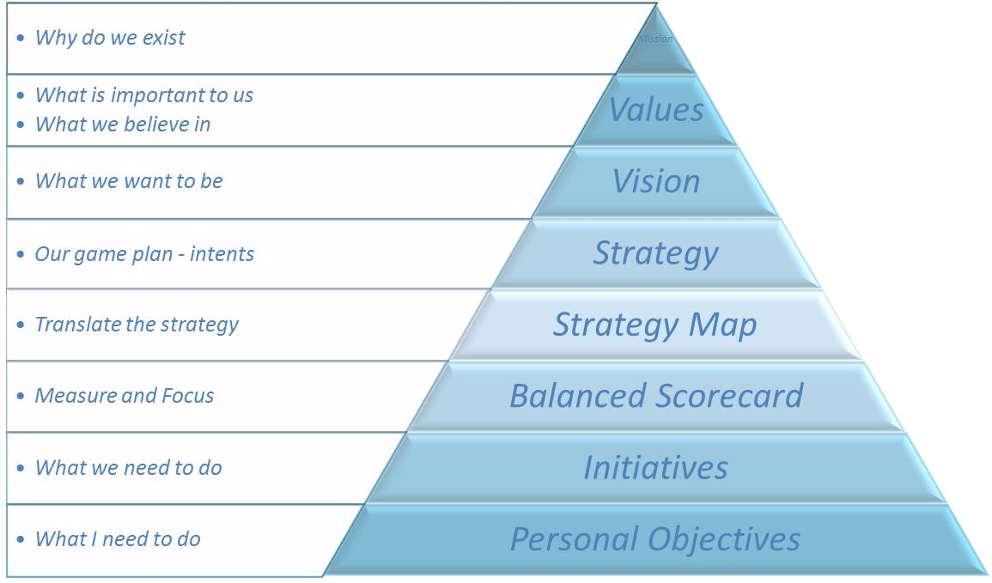

Vision Statement or BHAG – Big Hairy Audacious Goal

The vision statement of the PAO encapsulates where it aspires to be in the future. The vision statement is long term, and a stretch but must also be achievable through a well-crafted strategy.
Top Tip
the vision statement must be easy to remember and well understood by its stakeholders.
The BHAG is similar to the vision statement and some examples are:
- Amazon: Every book, ever printed, in any language, all available in less than 60 seconds.
- Google: Organize the world's information and make it universally accessible and useful
- Sony: Embody changing the image of Japanese products as being of poor quality; create a pocket transistor radio
- Microsoft: A computer on every desk and in every home
- Motorola: Sell 100,000 TVs at $179.95
Some examples of vision statements from Accountancy organisations in Africa and abroad
PAO | Vision Statement
ICAEW [England and Wales] | Our vision is to be acknowledged as the leading global accountancy and finance profession, so people can do business with confidence.
SIA [Swaziland] | To be the most admired professional institute in Swaziland – one that is sustainable and relevant to its members and stakeholders.
SAICA [South Africa] | Develop responsible leaders
CICA [Canada] | Chartered Accountants (CAs) are Canada’s most valued, internationally recognized profession of leaders in senior management, advisory, financial, tax and assurance roles
New Zealand and Australia | Our vision is for Chartered Accountants Australia and New Zealand members to be valued as the trusted leaders in business and finance.
ICAI [India] | Become … the world’s leading accounting body, a regulator and developer of trusted and independent professionals with world class competencies in accounting, assurance, taxation, finance and business advisory services.
ICAG [Ghana] | - To be premier institute of Chartered Accountants in Africa by:  - Having a technically competent and appropriate membership;  - Providing services of the highest professional standards to industry, commerce and government;  - Being recognised for highest standards of competencies, integrity and excellence;  - Providing the best services to members and students; and  - Being accepted as an authoritative body in accountancy and financial matters.

Mission Statement
The Mission Statement represents the purpose of the PAO or its reason for existence.
It should include as a minimum, what its primary product or service, primary market and primary customer and what makes it different.

Top Tip
The mission statement must serve as an explanation to staff and other stakeholders as to what the PAO is about in the absence of the CEO or any of the senior management.

Examples of Mission Statements
PAO | Mission Statements
ICAEW | Helping you do business with confidence  - Access – provide qualifications and professional development  - Influence – share knowledge, insight and technical expertise  - Members – promote, develop and support our members  - Standards, - protect the quality and integrity of the profession
CICPA (China) | It’s major missions are:  - Providing services to its members  - Monitoring the service quality and professional ethics of members  - Regulating the CPA profession according to the relevant laws  - Coordinating the relationship within and beyond the CPA profession
ICAS (Scotland) | We are an educator, examiner, regulator, and thought leader. ICAS supports its members with technical advice, regulation and compliance support, career development tools, a free and comprehensive Information Service, member offers and discounts, courses, qualifications, events and accountancy news.
Uganda | To develop and promote the accountancy profession in Uganda and beyond.
Kenya | To develop and regulate the accountancy profession in Kenya through supporting the CPA(K) to be recognized globally as Competent Professionals who Add Value whilst Serving and Protecting the public interest, building sustainable institutional capacity to provide that support
Ghana | To produce professional accountants of the highest quality, ready to provide cutting edge services to their clients at all times and upholding the ethical values of the accountancy profession

Values
Values underpin the strategy of the PAO. This set of organisational values guide the organisation on how they must operate from a behaviour perspective. Examples of values are integrity, respect, responsibility, service excellence, etc.

Top Tip
Create few values that can be lived or exhibited by the leadership and staff. Try to start each meeting with a values discussion and have it on the agenda.

Business Model
A Business Model is a fantastic to articulate what the PAO is about in a single page. This describes the purpose of the PAO and how in interacts with it stakeholders in a high-level format.
See Business Model Toolkit

Critical Success Factors [CSFs]
The Critical Success Factors can also be regarded as ‘positive risks’. These CSFs would form the basis of a strategy map.

The Strategy Map
The Strategy Map describes the PAOs strategy in a single page. This is a powerful tool for articulating the strategy which uses the cause-and-effect way of describing the strategy.
This strategy map can be used to present to stakeholders (both internal stakeholders such as staff and external stakeholders such as members) and its strategy.
The strategy map represents the four quadrants or perspectives of a balanced scorecard. The names and number of quadrants can be changed to suit the PAO. However, for the purposes of this toolkit, we will focus on the following four quadrants:

Perspectives or Quadrants (and Strategic Intents)

Members and stakeholders perspective - To achieve our goals, how should we appear to our internal & external stakeholders/customers?

Organisation and Learning perspective - To achieve our mission, what must we do to ensure we support growth and learning?

Internal Business Process perspective - Within our business processes what would excellence look like?

Financial perspective - To succeed, how should we perform financially?

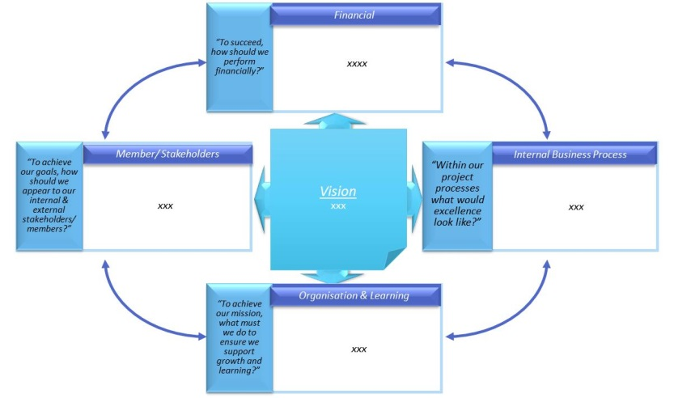
The Balanced Scorecard articulates the strategy map into key result areas (or the Critical Success Factors that we had previously identified), objectives, measurement, targets, frequency of measurement, and weights per measure.
For the purposes of the PAO, we will use an outputs based measurement or the use lag measures. The lead measures will be identified as projects, initiatives or operational activities that would result in the lag measure.
Top Tip
Learning Organisations – strategy formulation is a continuous journey. Crafting of scorecards require much discussion and deliberation so every effort made is a learning opportunity. Do not try to create sophisticated scorecards but rather reach consensus in achieving the measures in the short to medium term. This creates comfort and recognition of the process of winning. Thereafter more complex scorecards can be created.

Example 1 of a strategy map
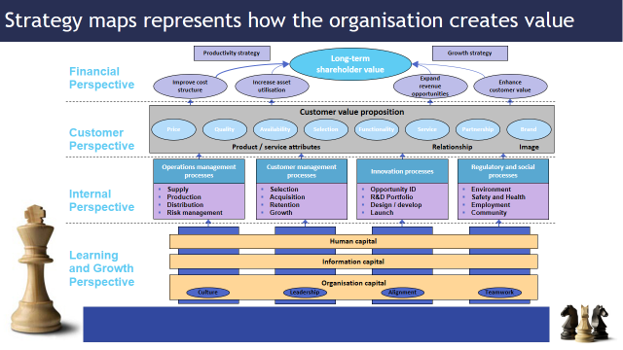

Example 2 of a strategy map
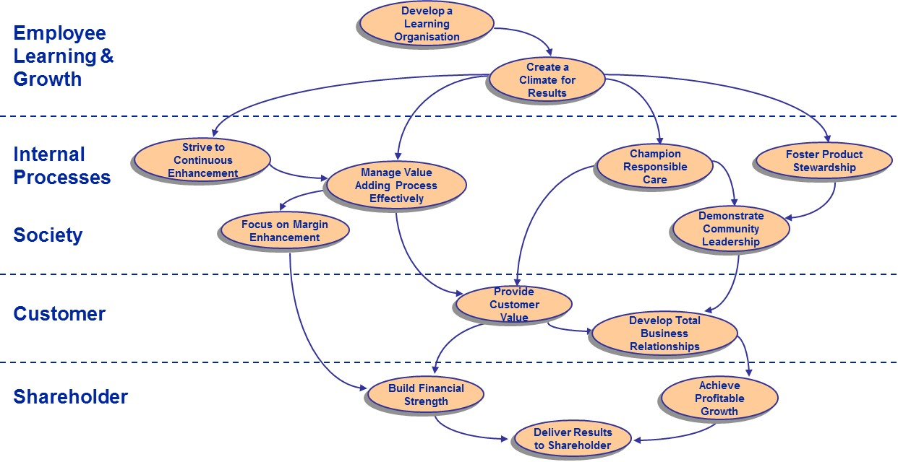

Example 3 of a strategy map
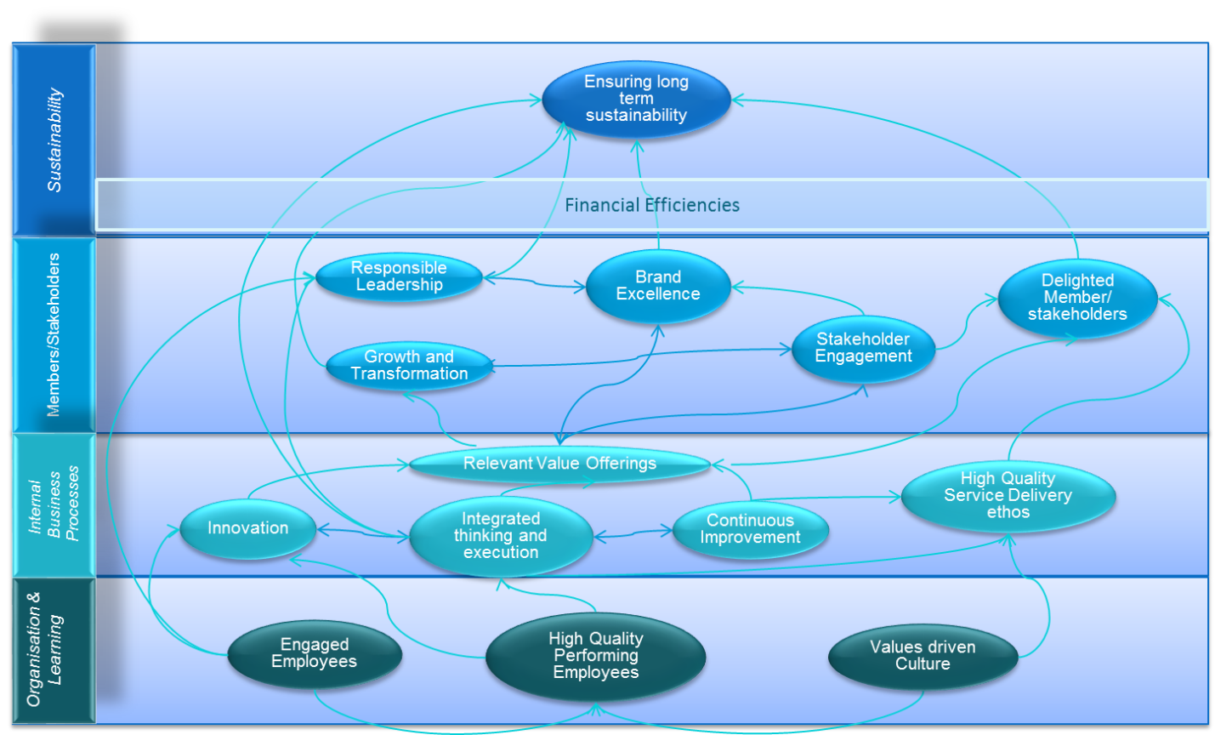

Example 4 of a strategy map
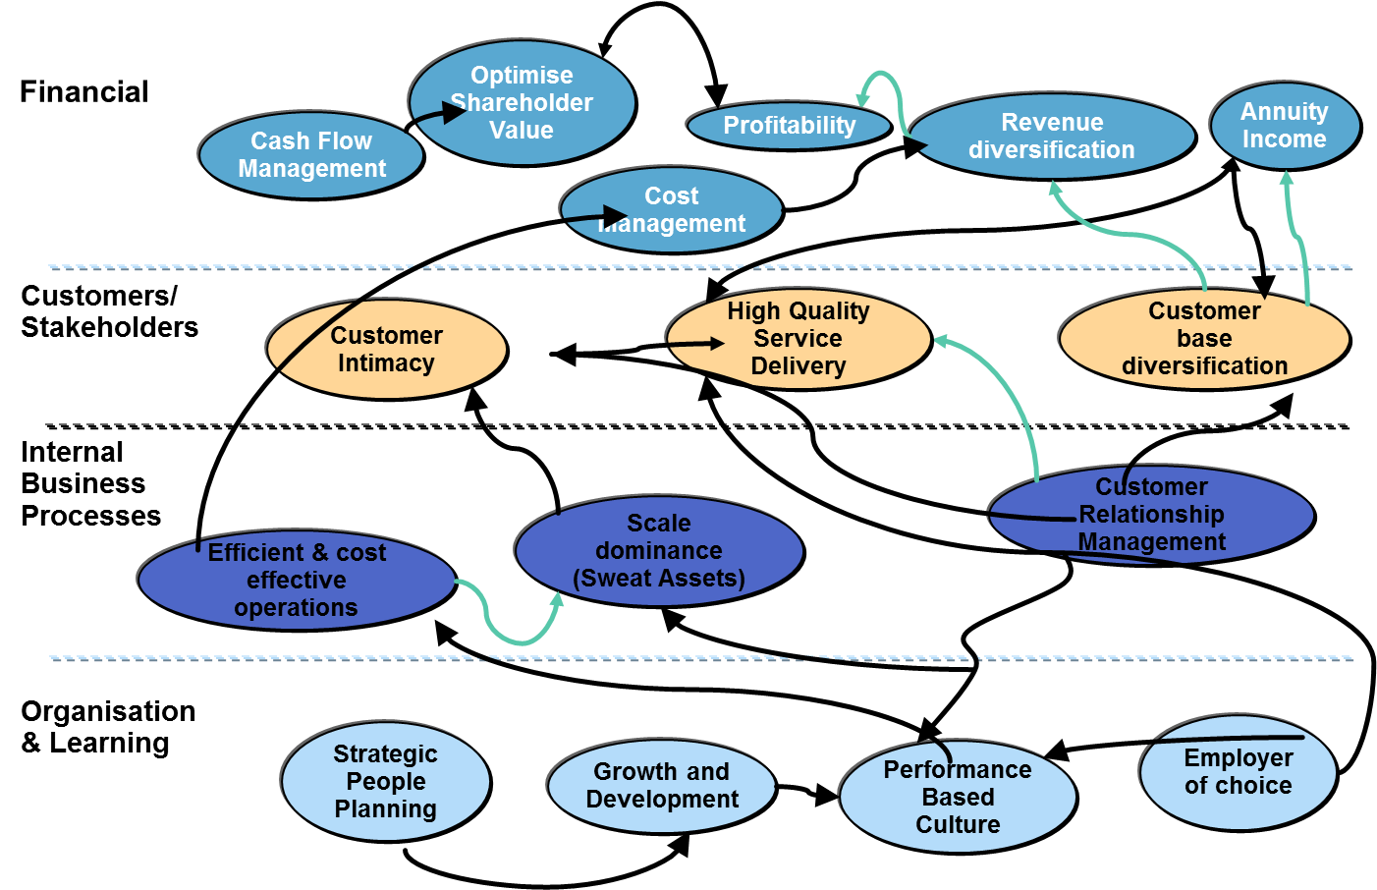

Measurement
Each measure that is crafted will have a Measure Detail Sheet (MDS). The MDS describes each measure, how it is exactly calculated, source documents, frequency, ownership and the initiatives to reach it.
Measures will be created for each quadrant/perspective. E.g financial perspective or Organisation and Learning perspective.
Please note that the CSFs (Critical Success Factors) are also known as KRAs (Key Result Areas.)

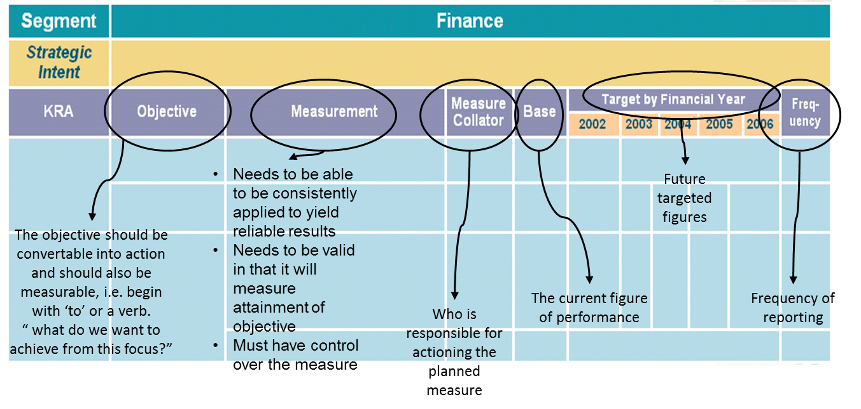
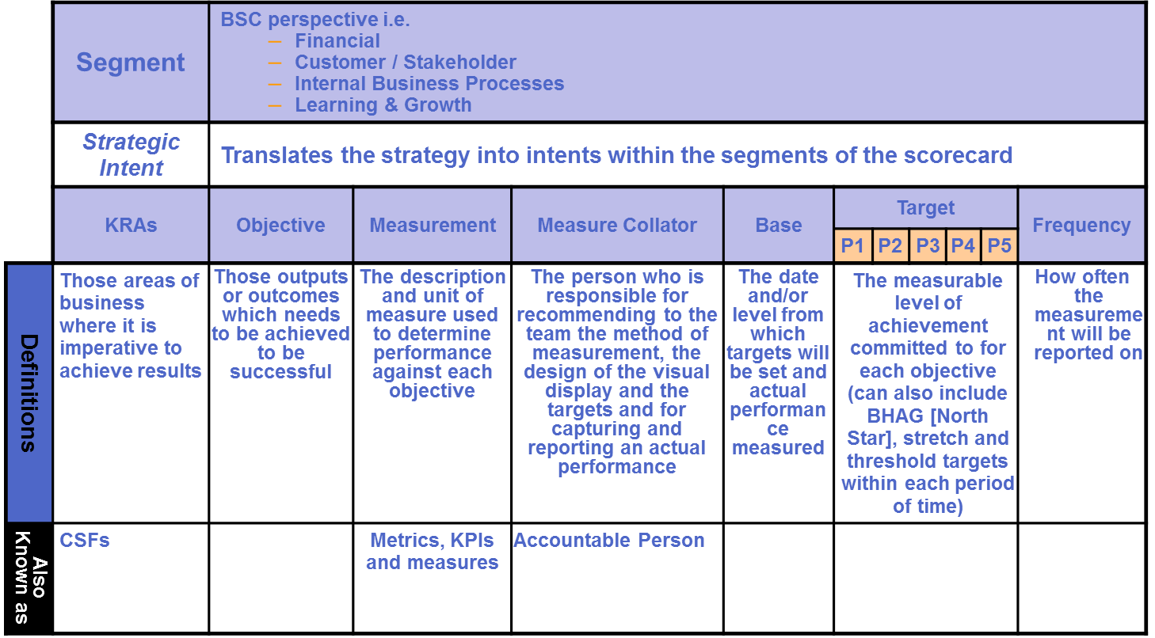

Measures

The measures should follow the SMART criteria. The SMART criteria define a good measure.

Lead and Lag measures examples
Lead measures are those types of measures that measures things that lead to the goal; whereas the lag measure, actually measures the goal.
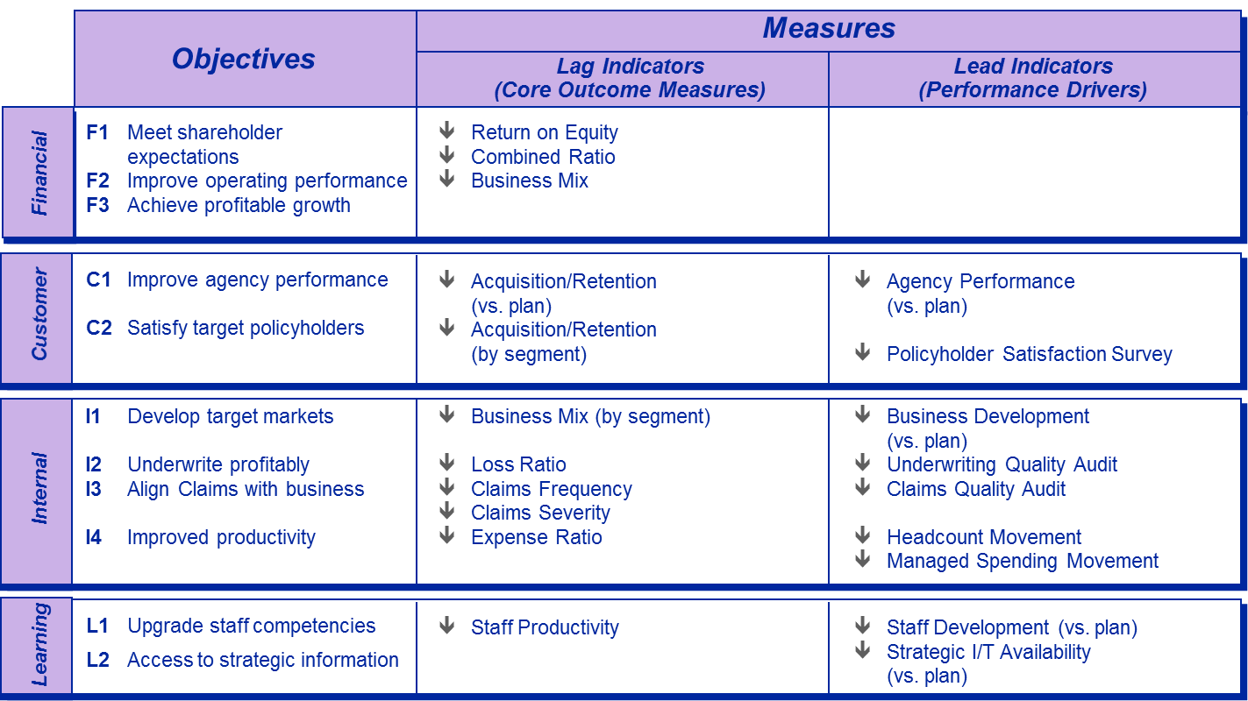

Targets
The criteria for a good target.

Measure detail sheet
The measure detail sheet is critical in defining the formula or calculation, the unit of measure, the frequency, the owner of the measure, the assumptions, the initiatives to reach the targets, the short, medium and long term targets.
Example of a measure detail sheet
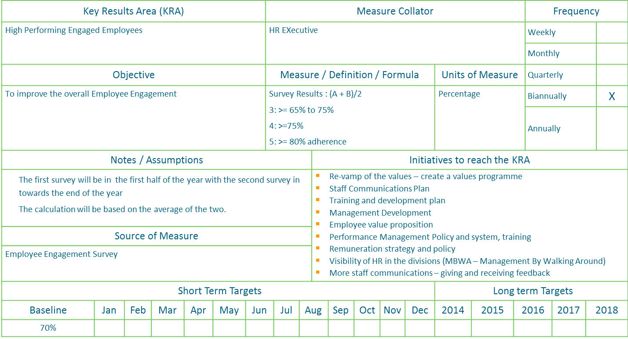

A typical Example of a Balanced Scorecard for a PAO
In the scorecard below are some measures that can be used by the PAO. The measures used below have a balance of lead and lag measures. In the begin of the PAO’s scorecard development, it would be great to start with some lead measures to get the ball rolling.
In doing the measures, please consider the various capitals such as Intellectual, Social, Manufactured (Physical), Human, Financial, Social and Relationship and Natural Capital (waste, carbon emissions, etc).
Throughout the scorecard development, take into account the IT (or digital) considerations.
Objective | Measurement | Measure Collator | Base | Target | Frequency | Weight | 1  Not Achieved | 2  Partially Achieved | 3  Achieved | 4  Achieved Stretch | 5  Exceeded Stretch | Initiatives (lead indicators)
To increase revenue by revenue diversification | Revenue | CEO | US$10m | 20% | Annually | 10% |  |  |  |  |  | Advertising and sponsorship revenue  Increased events
To increase Profit Margin of Services [assists in cross-subsidisation of strategic projects] | Profit Margin | Marketing Director |  | 10% | Monthly | 10% |  |  |  |  |  | High Value events
To increase the pipeline | Number of new pupils studying accounting | Marketing Director |  | 15% increase | Annually | 10% |  |  |  |  |  | School awareness campaigns, University awareness campaigns, Create awareness
To increase the membership base | Eligible Pool (Members) | Marketing Director |  | 10% | Monthly | 10% |  |  |  |  |  | Campaign to attract the eligible pool
To increase the satisfaction of members | Member Satisfaction Index | Marketing Director |  | 10% | Bi-Annually | 10% |  |  |  |  |  | Conduct a survey and establish a base
To increase engagement with members | Adherence to Communications Plan | Marketing Director |  | Xx% improvement | Monthly |  |  |  |  |  |  | Develop a Communications Plan and measure adherence
To engage with Stakeholders | Adherence to Stakeholder Management Plan | CEO | N/A | 90% adherence to plan | Monthly |  |  |  |  |  |  | Develop a Stakeholder Management Plan & measure adherence
To set accounting and Auditing standards | Adherence to the Plan | Professional Development Director | N/A | >90% adherence to plan | Monthly | 5% |  |  |  |  |  | Develop a plan to set the standards
To be compliant with SMO | SMO Plan | Professional Development Director | N/A | 60% compliance in year One | Monthly | 5% |  |  |  |  |  | Review and action the items on the SMO Plan
To improve the employee value proposition and keep the employees engaged | Adherence to Employee Value Proposition or Employee Engagement Plan | HR Directors | N/A |  | Monthly | 5% |  |  |  |  |  | Develop an employee value proposition and/or an employee engagement programme
Employee Engagement | Employee Engagement Index | HR Director | N/A |  | Bi-annually | 5% |  |  |  |  |  | Develop the survey and conduct it bi-annually with staff

Roadmap of Initiatives
Each measure would have targets. In order to achieve these targets, the PAO would need to identify projects or initiatives.
For example, the measure of improving the revenue diversification can include initiatives such as:
- Advertising and sponsorship
- The launch of an International Conference
- The launch of CFO Awards
- An Affinity or Lifestyle programme for the members
- Etc.
Each of these initiatives would need to be scoped, with a set of milestones, activities, deliverables and the team. These would be mapped onto a project charter.

Bringing it all together
In this design phase, a lot of work was done to craft the PAO strategy. The strategy is by no means perfect, but it would have been a journey and experience in self-discovery. Strategy is an iterative process and it must continuously be reviewed.
The deliverables for this phase are:
- Vision, Mission and values
- The PAO’s Business Model
- The Strategic Intents
- The Strategy Map
- The PAO’s Balanced Scorecard
- A Roadmap of initiatives

Implementation Planning
During the strategy design phase, there would have been lots of ideas, initiatives and projects. These would serve as inputs to the outputs-based (lag) measures. We call this a roadmap of strategic initiatives or projects that must be executed so that the PAO reaches its targets for the measures.

In order to ensure that the PAO meets its objectives, it would need to mobilise the inputs (projectise). The PAO can projectise by creating separate project charters. Projects, by definition, is a unique endeavour and has a definite start and end date. The project can have multiple deliverables, milestones, project resources, associated risks and critical success factors.
Each project should have a project champion and project manager. Remember that each project does not necessarily require a new human resource and existing operational resources can also be used, but just using a project approach for execution.
The project charter is used to mobilise the project.

Charter
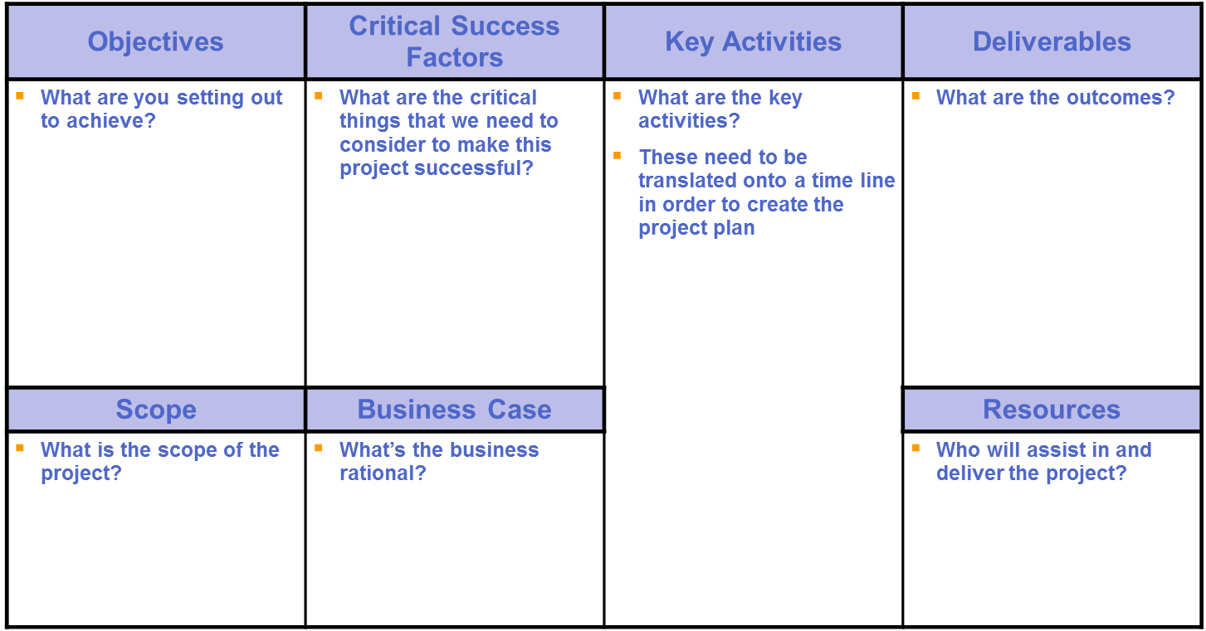

Resourcing
In order to mobilise the strategy, resources would be needed. There would be project resources that might double up as both operational and project resources. Nevertheless, there may be a need for more permanent resources in the PAO.
Below is a typical organogram that can be used to mobilise resources.

Typical organogram
Council
Professional Development Director | Technical Director | Marketing and Communications Director | Legal and Governance Director | Monitoring and Compliance Director
Development  IFAC SMO compliance  Pipeline management  Curriculum ‘development’ and advice  Stakeholder Management  CPD | Development of standards  Thought Leadership  Lobbying and influencing standards  Management of Technical Committees  Comments on exposure drafts  Compilation of papers/articles/publications  Stakeholder management  CPD (seminars, events, and workshops) | Marketing and communications strategy  Creation of Products and Services  Career awareness campaigns  Advertising and sponsorship  Management of Paper (magazines) and online publishing  Member Satisfaction Index  Brand Management | Committee assistant  Company secretarial  Promote the Ethics function  Disciplinary | Conduct audit and financial statement reviews of public interest companies  IFRS review services to regulators  Quality reviews – build Methodology, show benefits, show common findings  Conduct practice reviews  Development of audit manual  Conduct training

Stakeholder Management
Although resources may be allocated to strategic initiatives and projects, key stakeholder relations will need to be fostered. These key stakeholders would serve as a critical success factor achieving the PAOs strategic goals.
The stakeholder Management plan below is a description of what goes into a Stakeholder Management Plan. This plan must therefore be updated by the PAO during their Plan, Do, Review session.
Below is a sample template for a stakeholder management plan.
The current status column must be filled in as supporter, critic, neutral or blocker. The Strategic Objectives must be listed so that it ties back to strategy. The “What” column must include what will be discussed at the meetings. The “Who” column will be the person who will be responsible for engaging with the stakeholder.

Stakeholder | Stakeholder Name | Current status | Strategic objectives | What | Who | When | Achieved
Identify the stakeholder  e.g Department of Education | Identify the stakeholder’s name e.g. Mr John Doe | Blocker, Critic, Neutral, Supporter  [this identifies the status of the stakeholder] | Link the strategic objective from the balanced scorecard or strategic initiative.  e.g. School Awareness Campaign | Identify exactly what will be discussed at the meeting | Identify who will best represent the PAO | Determine a date and time | This will be a status indicator if the objective and ‘what’ has been achieved.
 |  | The stakeholder for example can be recognised as a blocker to the strategic objective and due care would have to be taken. This stakeholder map should therefore be strictly confidential, as the stakeholder may be offended to be recognised as a blocker.

Risk Schedule
During the strategy current assessment and design, the PAO would have identified various risks that might have been considered and mitigated to a certain extent in the strategy. However, a risk schedule should still be maintained and considered at every Plan, Do, Review (PDR) session of the strategy.
Risk Identification | Risk Category | Pure Risk Rating | Mitigation Controls | When | Risk Owner | Residual Risk Rating | Status
Describe the type of risk that has been identified | E.g. Financial, Strategic risk, Operational, Reputational, etc | Determine the risk rating: a number between 1 (being low risk) and 100 (being high risk) | Identify the steps that would be taken to lower the risk identified | When will these steps be done | Who will do the actions | What is the new risk rating after the risk has been mitigated (a number between 1 and 100). | Red (no improvement or risk worsened), Yellow (some improvement but something to watch carefully), Green (on track).

Communications Plan

The aim of the communications plan is to deliver the right information, to the right people, at the right time, using the appropriate channels. Whilst the communications objectives are linked to the strategic goals of the PAO, it also links it back to the PAO values as means to live it.
Some main stakeholder groups are identified as below: [build on the stakeholder groupings below]

Communication objective | Key Message(s) | Audience (Who?) | Channel (How?) | When
To increase the awareness of school pupils of the accountancy profession | Choose Accountancy | Grade 7 (because this is when they choose subjects for the following year) | Examples of channels [Bulk email, website,  Newspaper, radio, website  Facebook, Twitter, website, Face-to-face, LinkedIn, Twitter,  magazines, television, SMS]

The critical success factors for the communication plan are:

Budgets

The budgets should be in the form of running the business, growing the business and transforming the business. The first two are typically Operational Expenditure and the latter being longer term with capital investments.
Project budgets can be assigned with the acknowledgement that projects by definition, are unique in nature, is a temporary endeavour with a definite start and end date.

Bringing it all together
This phase in this strategy toolkit brings all of the strategic thinking into action plans. All good strategies define exactly how it will execute on the strategy. In this phase, the implementation planning tools were used to ensure that the critical success factors of the strategy would be achieved.
In this phase, the deliverables will be the:
- A Roadmap of initiatives
- The Charters
- Budgets
- Resource Plan
- Risk Schedule
- Stakeholder Management Plan
- Communications Plan
The strategy toolkit must continuously evolve and be shared with the other PAOs. The robustness of the strategies comes through in strategic choices and strategic conversations.
All the best in the strategy crafting!

Monitoring and Evaluation
The execution of the strategy is equally important as the crafting or the formulation of the strategy. Therefore, this phase is important as it includes the continuous re-assessment of the plan, the execution and the review.

Plan, Do, Review
The PAO must continuously Plan, Do, and Review its strategy roadmap and balanced scorecard on a monthly basis.

The Process
- Each measure must be evaluated.
- If there are reasons for variance, it must be reported.
- The Next Steps (plans of action), Who (would execute the plan) and When (will it be done) must be agreed upon.

By way of example

Measure and Target | Reason for Variance | Next Steps | Who | When
Revenue | 10% less attendees are taking up the seminar | - Contact potential seminar candidates  - Alter the marketing campaign to include a discount | Event administrator  Marketing Director | dd/mm/yyyy  dd/mm/yyyy

A PDR (Plan, Do, Review) toolkit is available to guide the PAO.

Project Management
Included in this methodology is the Project Management toolkit that helps the PAO to projectise and deliver on its strategy. This is a simple toolkit that keeps everything to one page.
The project toolkit includes:
- The Project Charter
- Scope Statement
- Project Risk Schedule
- Project Benefits
- Project Progress Report
- Key Lessons learned (when the project is complete)
See Project Toolkit

Bringing it all together
The final phase in this strategy toolkit, brings all of the strategic thinking into action plans. All good strategies define exactly how it will execute on the strategy. In this phase, the implementation planning tools were used to ensure that the critical success factors of the strategy would be achieved.
In this phase, the deliverables would be the:
- Plan, Do, Review sessions
- Project Charters, Project Scope, Project Benefits, Project Risk Assessment, Project Milestones, and Project Progress Reports.

